**High level design**

**Analysis of bike sale and its accessories**

**Shubham Kumar**

**21-10-2021**

Document Version Control………………………………………………………………………………2

Abstract…………………………………………………………………………………………………………..3

1. Introduction…………………………………………………………………………………………..4

1.1 Why this High-Level Design Document?

1.2 Scope

2. General Description………………………………………………………………………………5

2.1 Product Perspective & Problem Statement

2.2 Tools used

3 Design Details………………………………………………………………………………………………6

3.1 Functional Architecture……………………………………………………………………………..7

3.2 Optimization

4 KPIs

**Abstract**

Bike selling are an important reflection of the growing economy, and price of bike ranges are of great interest for both buyers and sellers. Ask a bike buyer to describe their dream bike and they probably won’t begin with the budget of the bike or the Brand of company. But for young people choice are best design and looking good body structure of bike. In this company parallel focus on the selling accessories bike.

.

1. **Introduction**

**1.1 Why this High-Level Design Document?**

The purpose of this High-Level Design (HLD) Document is to add the necessary detail to the current project description to represent a suitable model for coding. This document is also intended to help detect contradictions prior to coding, and can be used as a reference manual for how the modules interact at a high level.

The HLD will:

* + - Present all of the design aspects and define them in detail
    - Describe the user interface being implemented
    - Describe the hardware and software interfaces
    - Describe the performance requirements
    - Include design features and the architecture of the project
    - List and describe the non-functional attributes like:
      * Security
      * Reliability
      * Maintainability
      * Portability
      * Reusability
      * Application compatibility
      * Resource utilization
      * Serviceability

**2. Scope**

The HLD documentation presents the structure of the system, such as the database architecture, application architecture (layers), application flow (Navigation), and technology architecture. The HLD uses non-technical to mildly-technical terms which should be understandable to the administrators of the system.

1. **General Description**

**2.1 Product Perspective & Problem Statement**

Housing prices are an important reflection of the economy, and housing price ranges are of great interest for both buyers and sellers. In this project, house prices will be predicted given explanatory variables that cover many aspects of residential houses.

The objective of the project is to perform data visualization techniques to understand the insight of the data. This project aims apply various Business Intelligence tools such as Tableau or Power BI to get a visual understanding of the data.

Tools uses

Business Intelligence tools and libraries works such as Numpy, Pandas, Excel, R, Tableau, and Power BI are used to build the whole framework.









# Design Details

# Functional Architecture

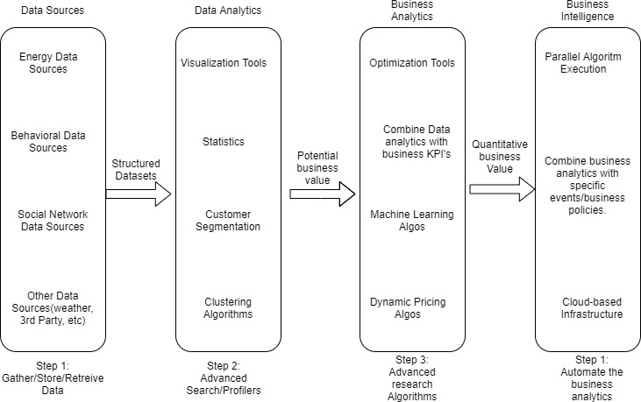

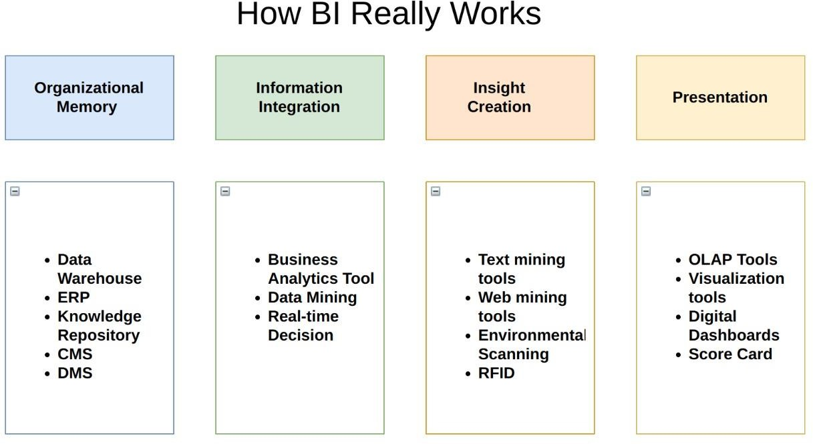

Your data strategy drives performance

• Minimize the number of fields

• Minimize the number of records

• Optimize extracts to speed up future queries by materializing calculations, removing columns and the use of accelerated views

Reduce the marks (data points) in your view

• Practice guided analytics. There’s no need to fit everything you plan to show in a single view. Compile related views and connect them with action filters to travel from overview to highly-granular views at the speed of thought.

• Remove unneeded dimensions from the detail shelf.

• Explore. Try displaying your data in different types of views.

Optimize and materialize your calculations

• Perform calculations in the database

• Reduce the number of nested calculations.

• Reduce the granularity of LOD or table calculations in the view. The more granular the calculation, the longer it takes.

o LODs - Look at the number of unique dimension members in the calculation.

o Table Calculations - the more marks in the view, the longer it will take to calculate.

• Where possible, use MIN or MAX instead of AVG. AVG requires more processing than MIN or MAX. Often rows will be duplicated and display the same result with MIN, MAX, or AVG.